Water Quality Monitoring System Based on IOT

**Department of Information and Technology,**

**Bapatla Engineering College :: Bapatla**

### Presented by,

*P.V.B.GANESH*

*P.V.B.KUMAR*

*CH.NAGA SUPRIYA*

# Abstract

Water pollution is one of the biggest fears for the green globalization. In order

to ensure the safe supply of the drinking water the quality needs to be monitor

in real time. In this paper we present a design and development of a low cost

system for real time monitoring of the water quality in IOT(internet of

things).The system consist of several sensors is used to measuring physical

and chemical parameters of the water. The parameters such as temperature,

PH, turbidity, flow sensor of the water can be measured. The measured values

from the sensors can be processed by the core controller. The Arduino model

can be used as a core controller. Finally, the sensor data can be viewed on

internet using WI-FI system.

Keyword: pH sensor, Turbidity sensor, Temperature sensor, Flow sensor,

Ardurino model, WI-FI module.

# I. INTRODUCTION:

In the 21st century, there were lots of inventions, but at the same time were pollutions,

global warming and so on are being formed, because of this there is no safe drinking

water for the world’s pollution. Nowadays, water quality monitoring in real time faces

challenges because of global warming limited water resources, growing population, etc.

Hence there is need of developing better methodologies to monitor the water quality

parameters in real time[1]. The water quality parameters pH measures the concentration

1108 Vaishnavi V. Daigavane and Dr. M.A Gaikwad

of hydrogen ions. It shows the water is acidic or alkaline. Pure water has 7pH value, less

than 7pH has acidic, more than 7pH has alkaline. The range of pH is 0-14 pH. For

drinking purpose it should be 6.5-8.5pH. Turbidity measures the large number of

suspended particles in water that is invisible. Higher the turbidity higher the risk of

diarrheoa, collera. Lower the turbidity then the water is clean. Temperature sensor

measures how the water is, hot or cold. Flow sensor measures the flow of water through

flow sensor. The traditional methods of water quality monitor involves the manual

collection of water samples from different locations.

The rest of this paper is organised as follows: section II review the related work of this

project, section III describes the proposed system with the modules explanation, section

IV provides the Schematic circuit with it working, Section V shows the results and

discussion, section VI the conclusion with future scope.

# II. LITERATURE REVIEW

Nikhil Kedia entitled “Water Quality Monitoring for Rural Areas-A Sensor Cloud Based

Economical Project.” Published in 2015 1st International Conference on Next Generation

Computing Technologies (NGCT-2015) Dehradun, India. This paper highlights theentire

water quality monitoring methods, sensors, embedded design, and information dissipation

procedure, role of government, network operator and villagers in ensuring proper

information dissipation. It also explores the Sensor Cloud domain. While automatically

improving the water quality is not feasible at this point, efficient use of technology and

economic practices can help improve water quality and awareness among people.[1]

Jayti Bhatt,Jignesh Patoliya entitled “Real Time Water Quality Monitoring System”.This

paper describes to ensure the safe supply of drinking water the quality should be

monitored in real time for that purpose new approach IOT (Internet of Things) based

water quality monitoring has been proposed. In this paper, we present the design of IOT

based water quality monitoring system that monitor the quality of water in real time. This

system consists some sensors which measure the water quality parameter such as pH,

turbidity, conductivity, dissolved oxygen, temperature. The measured values from the

sensors are processed by microcontroller and this processed values are transmitted

remotely to the core controller that is raspberry pi using Zigbee protocol. Finally, sensors

data can view on internet browser application using cloud computing.[2]

Michal Lom, Ondrej Pribyl, Miroslav Svitek entitled “Industry 4.0 as a Part of Smart

Cities”. This paper describes the conjunction of the Smart City Initiative and the concept

of Industry 4.0. The term smart city has been a phenomenon of the last years, which is

very inflected especially since 2008 when the world was hit by the financial crisis. The

main reasons for the emergence of the Smart City Initiative are to create a sustainable

model for cities and preserve quality of life of their citizens. The topic of the smart city

Water Quality Monitoring System Based on IOT

cannot be seen only as a technical discipline, but different economic, humanitarian or

legal aspects must be involved as well. In the concept of Industry 4.0, the Internet of

Things (IoT) shall be used for the development of so–called smart products. Sub-

components of the product are equipped with their own intelligence. Added intelligence is

used both during the manufacturing of a product as well as during subsequent handling,

up to continuous monitoring of the product lifecycle (smart processes). Other important

aspects of the Industry 4.0 are Internet of Services (IoS), which includes especially

intelligent transport and logistics (smart mobility, smart logistics), as well as Internet of

Energy (IoE), which determines how the natural resources are used in proper way

(electricity, water, oil, etc.). IoT, IoS, IoP and IoE can be considered as an element that

can create a connection of the Smart City Initiative and Industry 4.0 – Industry 4.0 can be

seen as a part of smart cities.[3]

Zhanwei Sun,Chi Harold Li,Chatschik Bisdikian,Joel W.Branch and Bo Yang entitled

“QOI-Aware Energy Management in Internet-of-Things Sensory Environments”. In this

paper an efficient energy management frame work to provide satisfactory QOI experience

in IOT sensory environments is studied. Contrary to past efforts, it is transparent and

compatible to lower protocols in use, and preserving energy-efficiency in the long run

without sacrificing any attained QOI levels. Specifically, the new concept of QOI-aware

“sensor-to-task relevancy” to explicitly consider the sensing capabilities offered by an

sensor to the IOT sensory environments, and QOI requirements required by a task. A

novel concept of the “critical covering set” of any given task in selecting the sensors to

service a task over time. Energy management decision is made dynamically at runtime, as

the optimum for long-term traffic statistics under the constraint of the service delay.

Finally, an extensive case study based on utilizing the sensor networks to perform water

level monitoring is given to demonstrate the ideas and algorithms proposed in this paper,

and a simulation is made to show the performance of the proposed algorithms.[4]

Sokratis Kartakis, Weiren Yu, Reza Akhavan, and Julie A. McCann entitled “Adaptive

Edge Analytics for Distributed Networked Control of Water Systems” This paper presents

the burst detection and localization scheme that combines lightweight compression and

anomaly detection with graph topology analytics for water distribution networks. We

show that our approach not only significantly reduces the amount of communications

between sensor devices and the back end servers, but also can effectively localize water

burst events by using the difference in the arrival times of the vibration variations

detected at sensor locations. Our results can save up to 90% communications compared

with traditional periodical reporting situations.[5]

## III. PROPOSED SYSTEM:

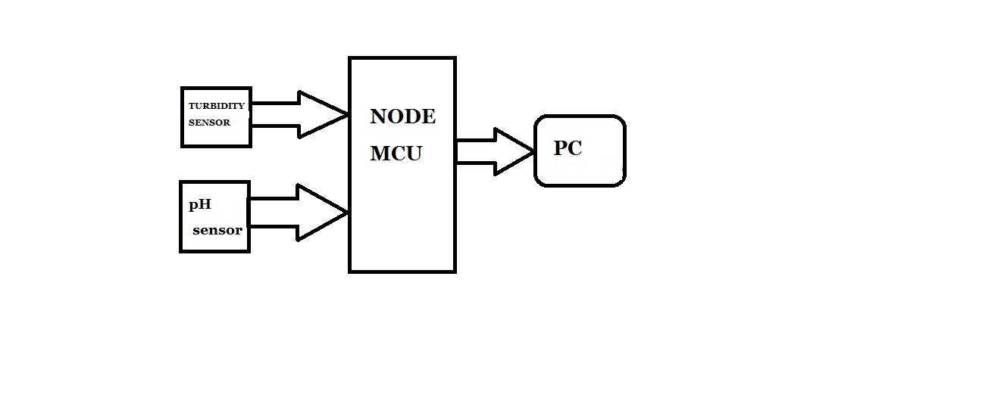 Fig: Block diagram of our project

In this, we present the theory on real time monitoring of water quality in IoT

environment. The overall block diagram of the proposed method is explained. Each

and every block of the system is explained in detail.

In this proposed block diagram consist of several sensors (temperature, pH, turbidity,

flow) is connected to core controller. The core controller are accessing the sensor

values and processing them to transfer the data through internet. Ardunio is used as a

core controller. The sensor data can be viewed on the internet wi-fi system.

pH sensor: The pH of a solution is the measure of the acidity or alkalinity of that

solution. The pH scale is a logarithmic scale whose range is from 0-14 with a neutral

point being 7. Values above 7 indicate a basic or alkaline solution and values below 7

would indicate an acidic solution. It operates on 5V power supply and it is easy to

interface with arduino.The normal range of pH is 6 to 8.5.

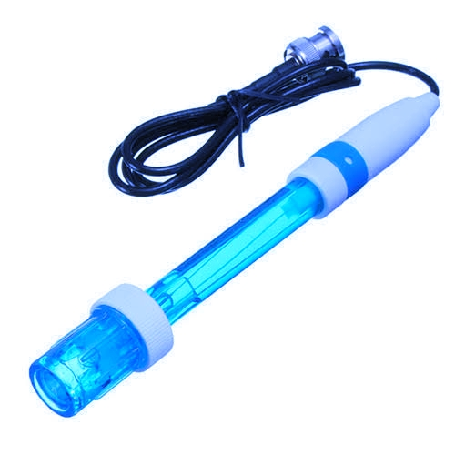

### Fig: pH sensor

a) Turbidity sensor: Turbidity is a measure of the cloudiness of water. Turbidity

has indicated the degree at which the water loses its transparency. It is considered

as a good measure of the quality of water. Turbidity blocks out the light needed by

submerged aquatic vegetation. It also can raise surface water temperatures above

normal because suspended particles near the surface facilitate the absorption of

heat from sunlight.

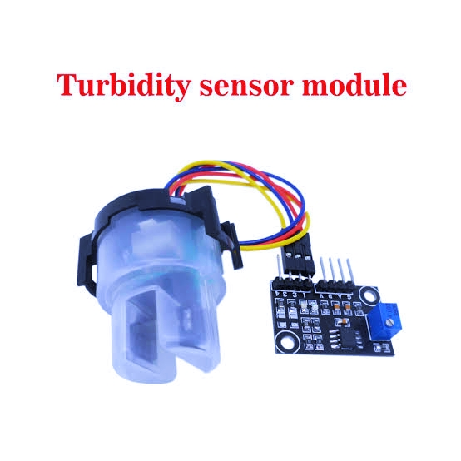

### Fig: Turbidity sensor

b) Temperature sensor: Water Temperature indicates how water is hot or cold. The

range of DS18B20 temperature sensor is -55 to +125 °C. This temperature sensor

is digital type which gives accurate reading.

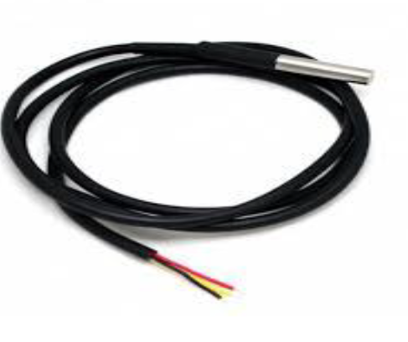

### Fig: Temperature sensor

c) Flow sensor:

Flow sensor is used to measure the flow of water through the flow

sensor. This sensor basically consists of a plastic valve body, a rotor and a Hall

Effect sensor. The pinwheel rotor rotates when water / liquid flows through the

valve and its speed will be directly proportional to the flow rate. The Hall Effect

sensor will provide an electrical pulse with every revolution of the pinwheel rotor.

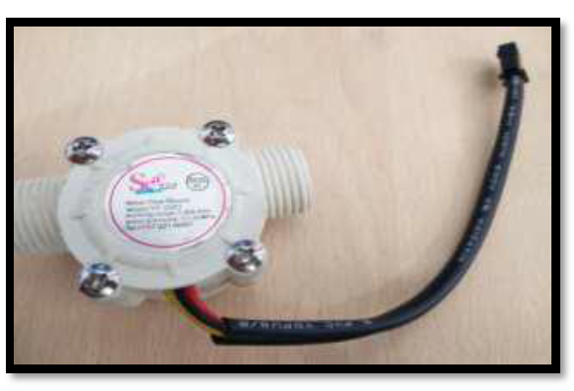

### Fig:Flow sensor

d) Arduino Uno:

Arduino is a microcontroller board based on the ATmega328P. It has

14 digital input/output pins (of which 6 can be used as PWM outputs), 6 analog

inputs, a 16 MHz quartz crystal, a USB connection, a power jack, an ICSP header and

a reset button. It contains everything needed to support the microcontroller. Arduino

Software (IDE) were the reference versions of Arduino, now evolved to newer

releases. The Uno board is the first in a series of USB Arduino boards, and the

reference model for the Arduino platform; for an extensive list of current, past or

outdated boards see the Arduino index of boards.

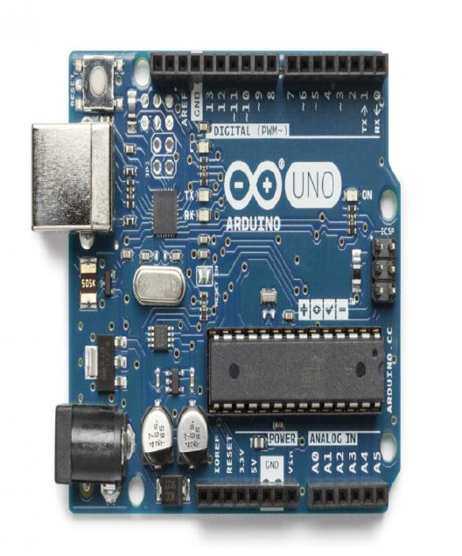

### Fig: Arduino uno

# e) Wi-fi module:

The ESP8266 Wi-Fi Module is a self contained SOC with integrated TCP/IP protocol

stack that can give any microcontroller access to your Wi-Fi network. The ESP8266 is

capable of either hosting an application or offloading all Wi-Fi networking functions

from another application processor. Each ESP8266 module comes pre-programmed

with an AT command set firmware. The ESP8266 module is an extremely cost

effective board with a huge, and ever growing, community.

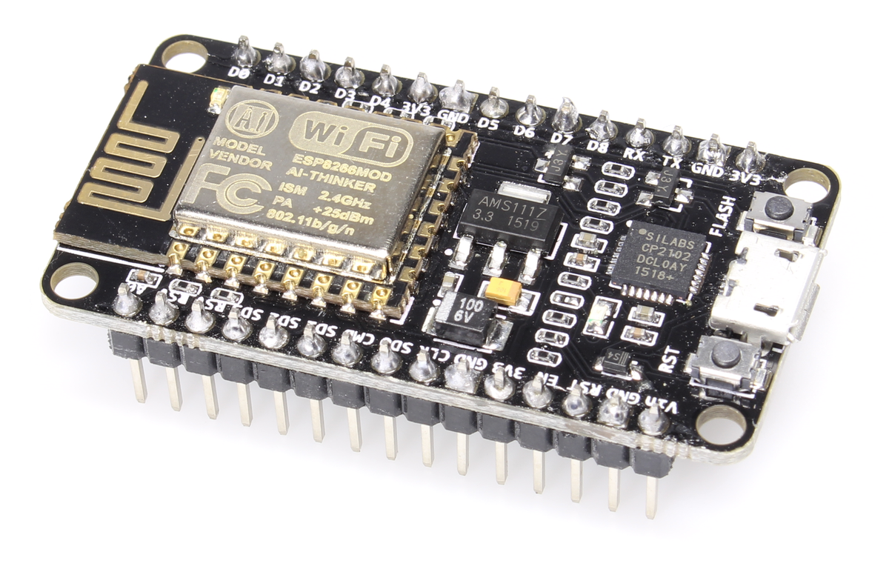

### Fig: Wi-Fi module

# IV. SCHEMATIC CIRCUIT WITH ITS WORKING

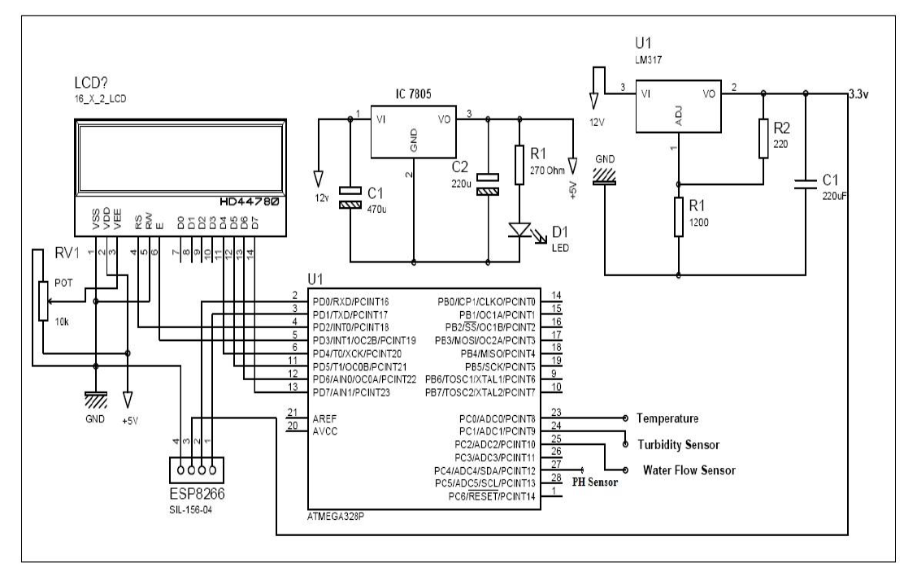

### Fig: schematic circuit

The whole design of the system is based mainly on IOT which is newly introduced

concept in the world of development. There is basically two parts included, the first

one is hardware & second one is software. The hardware part has sensors which help

to measure the real time values, another one is arduino atmega328 converts the analog

values to digital one, & LCD shows the displays output from sensors, Wi-Fi module

gives the connection between hardware and software. In software we developed a

program based on embedded c language.

The PCB is design at first level of construction and component and sensors mounted

on it. BLYNK app is installed in the android version to see the output. When the

system get started dc current given to the kit and arduino and WIFI gets on. The

parameters of water is tested one but one and their result is given to the LCD display.

The app went provided with hotspot gives the exact value as on LCD display shows

on kit. Thus like this when the kit is located on any specific water body and WIFI is

provided we can observe its real time value on our android phone anywhere at any

time.

# V. RESULT & DISCUSSION

We have identified a suitable implementation model that consists of different sensor

devices and other modules, their functionalities are shown in figure. In this

implementation model we used ATMEGA 328 with Wi-Fi module. Inbuilt ADC and

Wi-Fi module connects the embedded device to internet. Sensors are connected to

Arduino UNO board for monitoring, ADC will convert the corresponding sensor

reading to its digital value and from that value the corresponding environmental

parameter will be evaluated.

After sensing the data from different sensor devices, which are placed in particular

area of interest. The sensed data will be automatically sent to the web server, when a

proper connection is established with sever device.

# IV. SYSTEM DESIGN OF MODEL

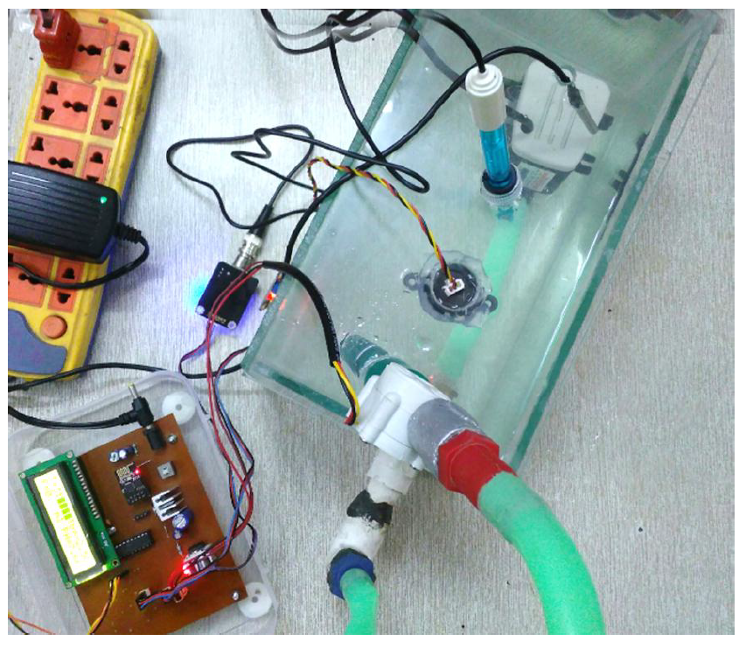

Fig: System design model of water quality monitoring system using IOT

# V. CONCLUSION AND FUTURE SCOPE

Conclusion: Monitoring of Turbidity, PH & Temperature of Water makes use of

water detection sensor with unique advantage and existing GSM network. The system

can monitor water quality automatically, and it is low in cost and does not require

people on duty. So the water quality testing is likely to be more economical,

convenient and fast. The system has good flexibility. Only by replacing the

corresponding sensors and changing the relevant software programs, this system can

be used to monitor other water quality parameters. The operation is simple. The

system can be expanded to monitor hydrologic, air pollution, industrial and

agricultural production and so on. It has widespread application and extension value.

By keeping the embedded devices in the environment for monitoring enables self

protection (i.e., smart environment) to the environment. To implement this need to

deploy the sensor devices in the environment for collecting the data and analysis. By

deploying sensor devices in the environment, we can bring the environment into real

life i.e. it can interact with other objects through the network. Then the collected data

and analysis results will be available to the end user through the Wi-Fi.

# Future Scope:

* In future we use IOT concept in this project
* Detecting the more parameters for most secure purpose
* Increase the parameters by addition of multiple sensors
* By interfacing relay we controls the supply of water

# REFERENCES

[1] Nikhil Kedia, Water Quality Monitoring for Rural Areas- A Sensor Cloud

Based Economical Project, in 1st International Conference on Next

Generation Computing Technologies (NGCT-2015) Dehradun, India, 4-5

September 2015. 978-1-4673-6809-4/15/$31.00 ©2015 IEEE

[2] Jayti Bhatt, Jignesh Patoliya, Iot Based Water Quality Monitoring System,

IRFIC, 21feb,2016.

[3] Michal lom, ondrej priby & miroslav svitek, Internet 4.0 as a part of smart

cities, 978-1-5090-1116-2/16/$31.00 ©2016 IEEE

[4] Zhanwei Sun, Chi Harold Liu, Chatschik Bisdikia_, Joel W. Branch and Bo

Yang, 2012 9th Annual IEEE Communications Society Conference on Sensor,

Mesh and Ad Hoc Communications and Networks

[5] (SECON), 978-1-4673-1905-8/12/$31.00 ©2012 IEEE

[6] Sokratis Kartakis, Weiren Yu, Reza Akhavan, and Julie A. McCann, 2016

IEEE First International Conference on Internet-of-Things Design and

Implementation, 978-1-4673-9948-7/16 © 2016IEEE

[7] Mithaila Barabde, shruti Danve, Real Time Water Quality Monitoring System,

IJIRCCE, vol 3, June 2015.

[8] Akanksha Purohit, Ulhaskumar Gokhale, Real Time Water Quality

Measurement System based on GSM , IOSR (IOSR-JECE) Volume 9, Issue 3,

Ver. V (May - Jun. 2014)

[9] Eoin O’Connell, Michael Healy, Sinead O’Keeffe, Thomas Newe, and Elfed

Lewis, IEEE sensors journal, vol. 13, no. 7, July 2013, 1530-437x/$31.00 ©

2013 IEEE

[10] Nidal Nasser, Asmaa Ali, Lutful Karim, Samir Belhaouari, 978-1-4799-

0792-2/13/$31.00 ©2013 IEEE

[11] Niel Andre cloete, Reza Malekian and Lakshmi Nair, Design of Smart Sensors

for Real-Time Water Quality monitoring, ©2016 IEEE conference.